1.Login form

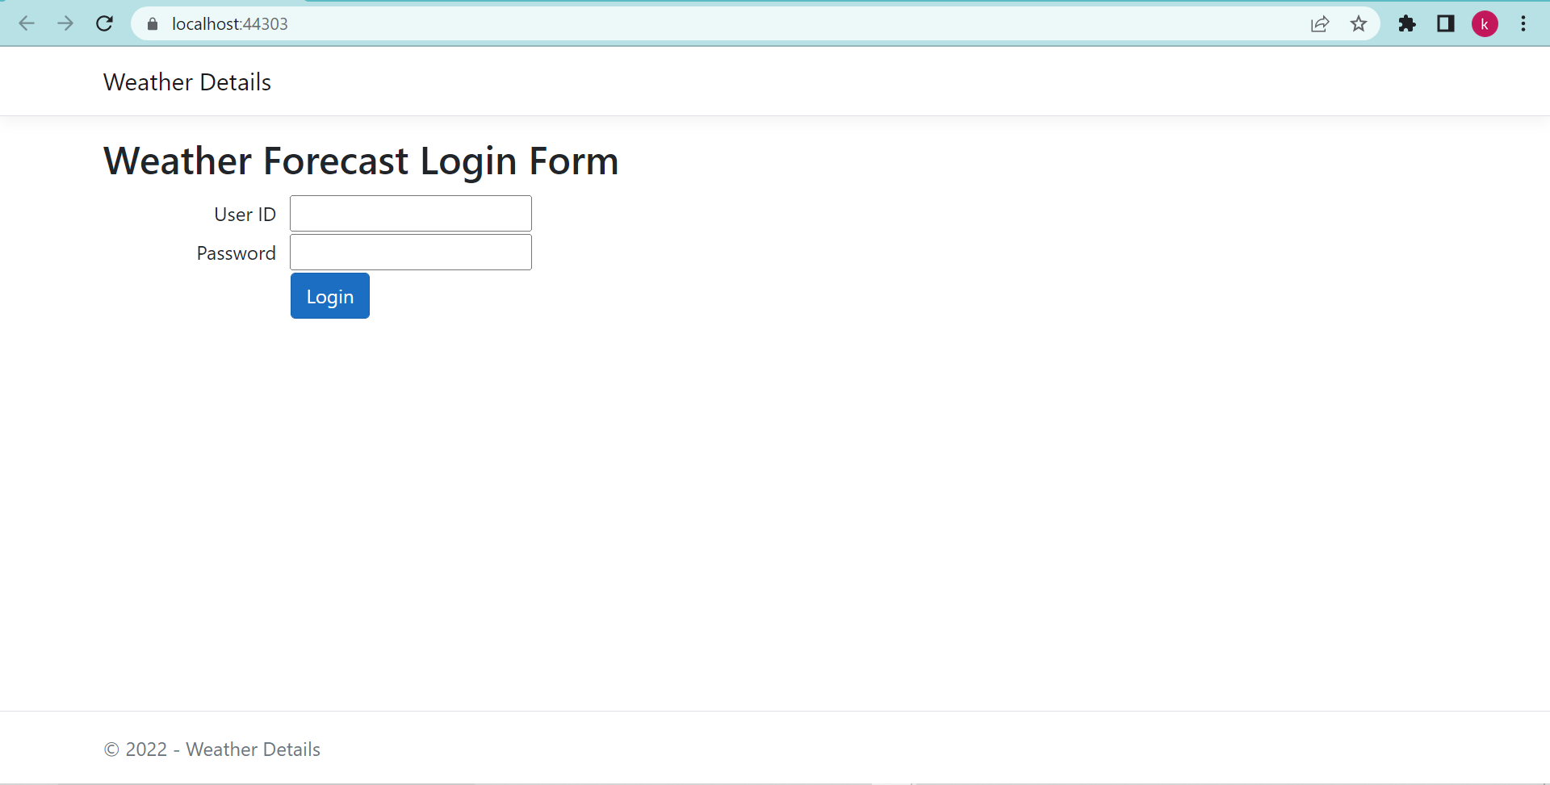

2. Please provide anyone of the following credentials and click on **Login** button.

**User ID:** Komali

**Password** : 1

Or

**User ID:** Komali1

**Password** : Komali987

3. Then you will get the following screen and please enter the city name in the text box and click on **Search** button

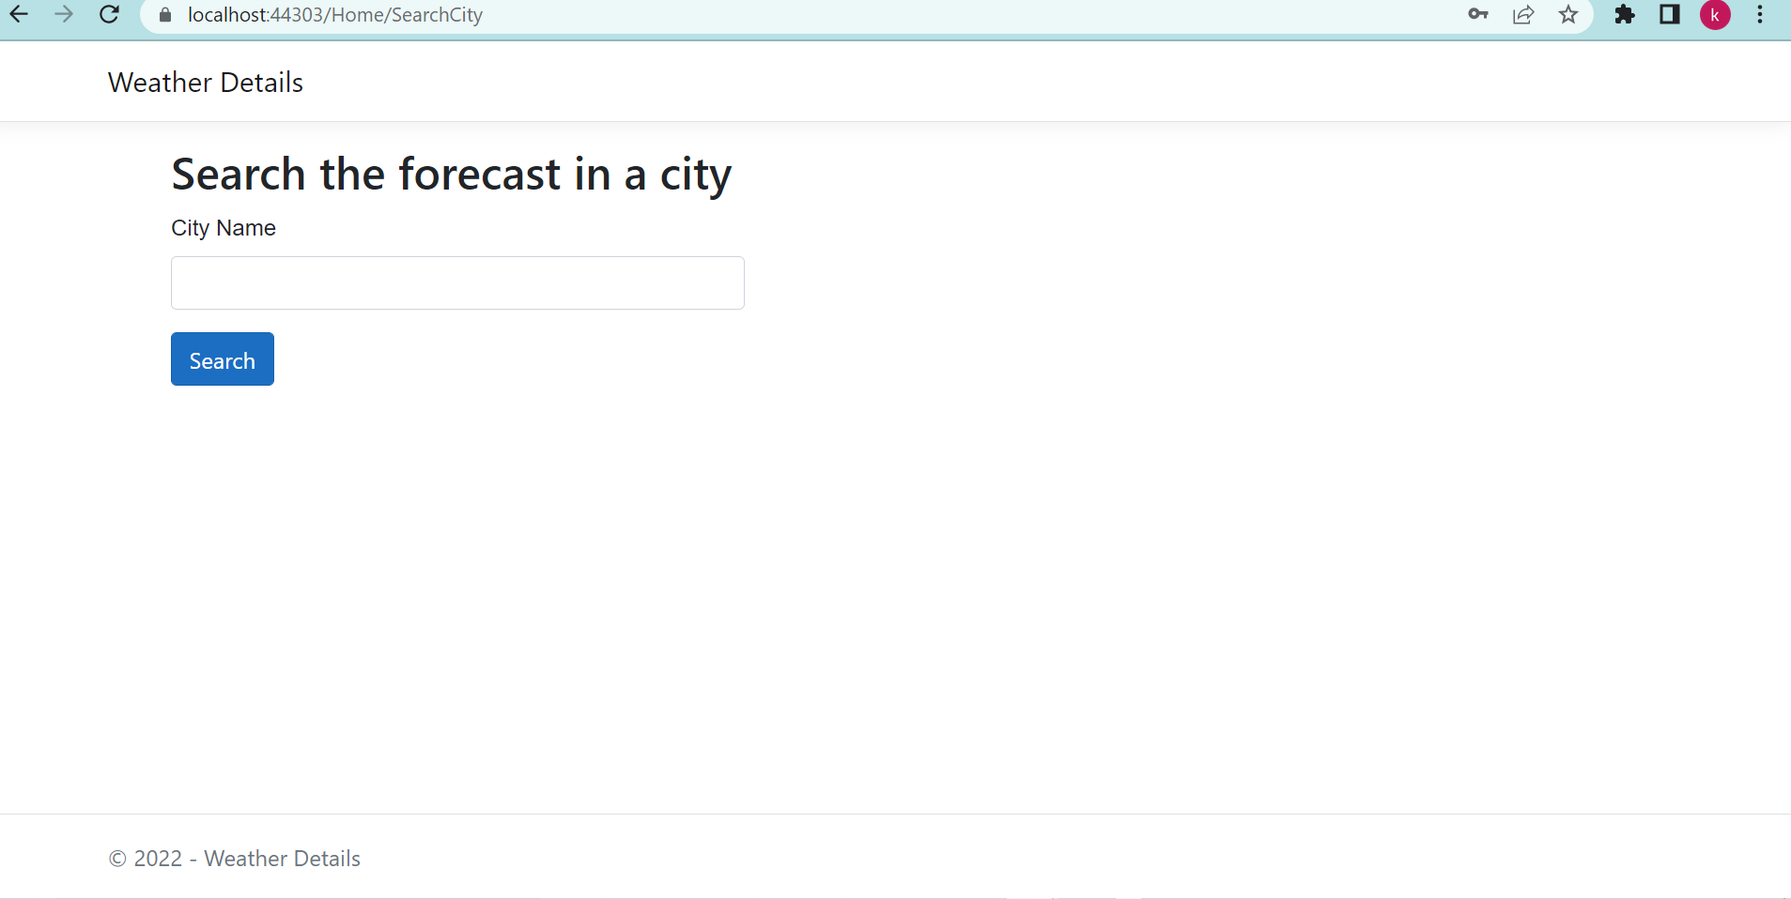

4. Finally, you will get the weather details of the area as following

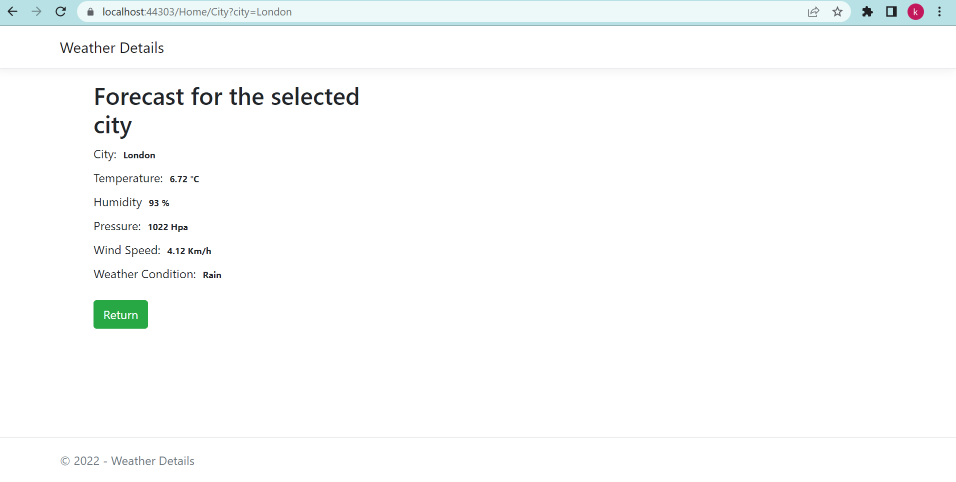

5. If you want to go back to the earlier screen, you can click on **Return** button to enter the other city name and can check for the weather details.